RICE HUSK POWDER COLLECTOR

PROJECT WORK I - PHASE I REPORT

Submitted by LOKESHWARAN K 22ECR095

MUTHU SHIBI K S
22ECR115

NAVEEN KUMAR P
22ECR118

in partial fulfilment of the requirements for the award of the degree

BACHELOR OF ENGINEERING IN
ELCTRONICS AND COMMUNICATION

DEPARTMENT OF ELECTRONICS AND COMMUNICATION ENGINEERING

Estd : 1984

KONGU ENGINEERING COLLEGE
(Autonomous)
PERUNDURAI, ERODE – 638060 MAY 2025

DEPARTMENT OF ELECTRONICS AND COMMUNICATION ENGINEERING
KONGU ENGINEERING COLLEGE
(Autonomous) PERUNDURAI, ERODE – 638060
MAY 2025

BONAFIDE CERTIFICATE

This is to certify that the Project work I Phase I report entitled RICE HUSK POWDER COLLECTOR is the Bonafide record of project work done by LOKESHWARAN K (22ECR095), MUTHU SHIBI K S (22ECR115), NAVEEN KUMAR P (22ECR118) in
partial fulfilment of the requirements for the award of the Degree of Bachelor of Engineering in Electronics and Communication Engineering of Anna University, Chennai during the year 2024 – 2025.

SUPERVISOR HEAD OF DEPARTMENT
Mr. S. SATHESH B.E., M.E., Dr. N. KASTHURI B.E., ME, Ph.D.,
Assistant Professor Professor & Head
Department of ECE Department of ECE
Kongu Engineering College Kongu Engineering College
Perundurai-638060 Perundurai-638060

Date:

Submitted for the end semester viva voce examination held on

INTERNAL EXAMINER EXTERNAL EXAMINER

DEPARTMENT OF ELECTRONICS AND COMMUNICATION ENGINEERING
KONGU ENGINEERING COLLEGE
(Autonomous) PERUNDURAI, ERODE – 638060
MAY 2025

DECLARATION

We affirm that the Project work I Phase I Report titled RICE HUSK POWDER COLLECTOR being submitted in partial fulfilment of the requirements for the award of Bachelor of Engineering is the original work carried out by us. It has not formed the part of any other project report or dissertation on the basis of which a degree or award was conferred on an earlier occasion on this or any other candidate.
Date: (Signature of the candidates)

LOKESHWARAN K
(22ECR095)

MUTHU SHIBI K S
(22ECR115)

NAVEEN KUMAR P
(22ECR118)

I certify that the declaration made by the above candidates is true to the best of my knowledge.

Date: Name and Signature of the Supervisor with seal

ABSTRACT

Rice husk powder is a byproduct that comes in the process of rice milling. In some rice mills, rice husk powder gets collected in large piles for further packaging process, making it hard to manage and clean. This project on the title of “Rice husk powder collector” uses a conveyor belt system with Wiper motor for loading the powder for the packaging process. It also has a load cell to continuously monitor the weight of the collected powder. The system uses an Arduino Nano to read the weight of the collected powder with the help of load cell and shows it on a Liquid Crystal display.
This provides a precise system and thus minimize labour force, provides a cleaner environment for working. This system is designed to be a simple mechanism thus can be implemented in small scale mills. The proposed system will be powered with the help of Switched Mode Power Supply for the conveyor system and a motor driver for the controller.
This system aims to be a simple and compact design thus can be easily modified for various types of materials. The real-time monitoring and controlled collection make it a suitable solution for scalable implementation in rice mills and agricultural-based industries. This system ultimately aims to reduce the labour force needed for loading the rice husk powder from the pile and also parallelly showing the weight for the user to easily the system with greater efficiency.

ACKNOWLEDGEMENT

First and foremost, we acknowledge the abundant grace and presence of the Almighty throughout different phases of the project and its successful completion.

We wish to express our hearty gratitude to our honourable Correspondent THIRU A.K. ILANGO B.Com., M.B.A., LLB., and other trust members for having provided us with all necessary infrastructures to undertake this project.

We express our hearty gratitude to our honourable Principal Dr. V. BALUSAMY B.E.(Hons)., M.Tech., Ph.D., for his consistent encouragement throughout our college days.

We would like to express our profound interest and sincere gratitude to our respected Head of the department Dr. N. KASTHURI B.E., M.E., Ph.D., for her valuable guidance.

A special debt is owed to the project coordinator Dr. K. MANOJ SENTHIL ME., Ph.D., Associate Professor and Ms. M. PONKARTHIKA M.E., Assistant Professor, Department of Electronics and Communication Engineering, for their encouragement and valuable advice that helped us to carry out the project successfully.

We express our sincere gratitude to our beloved guide Mr. S. SATHESH B.E., M.E., Assistant Professor, Department of Electronics and Communication Engineering, for his ideas and suggestions, which have been very helpful to complete the project.

We are grateful to all the faculty and staff of the Department of Electronics and Communication Engineering and those who had directly and indirectly supported this project.

 | TABLE OF CONTENTS
CHAPTER NO | TITLE | PAGE NO
1 | ABSTRACT  TABLE OF CONTENTS LIST OF FIGURES LIST OF TABLES  LIST OF ABBREVIATIONS  INTRODUCTION | iii v vii  viiii ix  1
 | Overview | 1
 | Objective | 1
2 | ABOUT THE INDUSTRY | 2
 | Industry details | 2
3 | LITERATURE SURVEY | 3
4 | EXISTING METHOD | 5
 | Manual loading | 5
5 | METHODOLOGY | 6
 | Working | 6
 | Block diagram | 7
 | Circuit diagram | 10
 | 3D Visualization | 11
 | System structure | 12
6 | SYSTEM COMPONENTS | 13
 | Components | 13
 | Software used | 13
7 | RESULTS AND DISCUSSION | 14
 | Powder collection | 14
 | Weight measurement | 17

Discussion 18
- CONCLUSION AND FUTURE SCOPE 19
- REFERENCE 20
IC01 FORM
ACCEPTANCE LETTER APPRECIATION LETTER

 | LIST OF FIGURES
FIGURE NO | FIGURE NAME | PAGE NO
1.1 | Rice husk powder pile | 1
5.1 | Block diagram | 7
5.2 | Switched mode power supply | 7
5.3 | Wiper motor | 8
5.4 | L298N motor driver | 8
5.5 | Conveyor belt | 8
5.6 | Load cell (80 Kg) | 8
5.7 | HX711 module | 9
5.8 | Arduino Nano | 9
5.9 | Liquid Crystal Display | 9
5.10 | Circuit diagram | 10
5.11 | 3D Model | 11
5.12 | Metal structure | 12
7.1 | Whole system | 14
7.2 | Powder collected from the pile | 15
7.3 | Powder dropping into the sack | 16
7.4 | Weight measuring system | 17

 | LIST OF TABLES
TABLE NO | TABLE NAME | PAGE NO
6.1 | Components used | 13

LIST OF ABBREVISTIONS

AC - Alternating current
SMPS - Switched Mode Power Supply LCD - Liquid Crystal Display
3D - Three Dimension

CHAPTER 1

INTRODUCTION

OVERVIEW
The process of rice milling is an important process that is done to provide the rice as a food. This rice milling process generates rice husk powder as a byproduct. In many rice mills, the collection of this husk powder is performed manually by piling up the powder in a desired area and loading whenever there is need for the powder, which is labour- intensive and time-consuming for heavy loading. Over the time, these piles of husk powder can become difficult to manage, which leads to a dusty environment which will be even harder for the manual workers to again load or clean the piled-up rice husk powder.
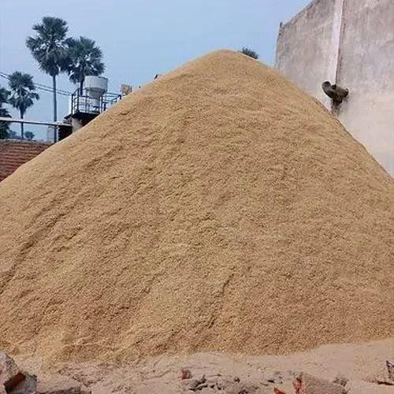
Fig. 1.1 – Rice husk powder pile

OBJECTIVE

The main aim of this project is to create a simple and low-cost system that can collect rice husk powder automatically. In many rice mills, the powder piles up and is difficult to handle manually. To solve this, we use a conveyor belt system that moves the powder and drops it into a sack. A load cell is used to measure the weight, and the weight is shown on a small display using an Arduino Nano. This setup helps workers know how much powder is collected, making the process easier and more organized. The system reduces manual work, saves time, and keeps the working area clean. It is easy to use and suitable for small rice mills without much expense.

CHAPTER 2 ABOUT THE INDUSTRY
Elgon Electrical and Electronics is a company located in Erode, Tamil Nadu. It mainly deals with electrical and electronic-related works and supports simple automation projects. The industry provided the task of designing and implementing a rice husk powder collector for a small-scale rice mill with low cost and easily operatable. They provided the necessary details and specifications of the design of the system.

INDUSTRY DETAILS

INDUSTRY NAME: ELGON ELECTRICAL AND ELECTRONICS

INDUSTRY PERSON:

INDUSTRY LOCATION: 23-K, EVK Sampath Road, 2nd Left, Erode Tamil Nadu, 638 003
PROBLEM STATEMENT: To design and implement a rice husk powder collector

CHAPTER 3

LITERATURE SURVEY

Lim et al. (2012) proposed an optimized design for rice mills that included a rice husk collection system. Their main aim was to reduce energy usage and improve the efficiency of transporting and handling rice husk within the mill. The system was planned at a large scale, focusing on energy optimization. The highlights of this paper is the importance of system- level design in improving overall productivity in rice mills.
Sharma et al. (2023) developed an automatic rice husk powder collection system using a conveyor belt and a load cell. The load cell allowed real-time monitoring of weight, which helped avoid overloading. They used microcontrollers to control the system and reduce human labor. This approach improved accuracy and efficiency, making it suitable for modern rice mills. The system shares similarities with the one proposed in our project.
Lee and Park (2018) designed a weight monitoring system using a load cell specifically for agricultural conveyor belts. Their system could read weight data in real-time and was built to work in outdoor farming environments. It showed how load cells could be used effectively even in rough conditions. The project was scalable and reliable, offering insights into smart agricultural automation.
Yadav and Jha (2021) presented a low-cost Arduino-based weight measurement system using the HX711 module and a load cell. Their design was simple and targeted small industries or farm-level use. It provided accurate weight readings and could be integrated with basic digital displays. This paper is highly relevant to our project, as it focuses on affordability and practicality.
Suryawanshi et al. (2018) implemented a smart conveyor system with weight sensing using Arduino. Their project allowed real-time monitoring and automatic response to weight changes on the belt. It helped reduce human effort by automating the weighing process. The integration of embedded systems with conveyor mechanisms showed how automation can improve traditional setups.

Sharma et al. (2022) demonstrated the use of a wiper motor in agricultural automation systems. Their work focused on the motor’s strength, cost-effectiveness, and ease of use with Arduino-based setups. It showed how such motors could be adapted for tasks like moving or collecting powdery materials. The findings support the use of wiper motors in small industrial applications like ours.
Chauhan et al. (2022) built a conveyor belt weight detection system mainly for packaging lines. They used sensors and automation to detect when the desired weight was reached and stop the belt. This avoided overfilling and ensured precision. Their system was accurate, reliable, and efficient for repetitive weighing tasks in industrial settings.
Zhang, Wang, and Li (2021) designed a conveyor weighing system that gave real-time feedback using load cells. Their system was used in an industrial setup and connected to microcontrollers for automatic control. It highlighted how continuous feedback can help maintain accurate control in fast-paced operations. This concept is useful for developing responsive systems in rice mills.
Kumar and Singh (2020) worked on an automated material handling system focused on rice husk collection. Their design minimized human effort and improved transportation within the mill. The system included features like automation and proper routing for husk movement. It aimed at increasing the speed and reducing the manual burden of husk handling.
Yadav and Jha (2021) developed another Arduino-based weight monitoring system using a load cell and HX711 module. It was aimed at low-cost and real-time measurement for industrial and agricultural uses. The setup was compact, simple, and gave accurate results, which makes it ideal for use in projects like rice husk collection systems.

CHAPTER 4 EXISTING METHOD
Rice husk powder, a byproduct of rice milling, is often difficult to manage due to its lightweight and dusty nature. In many small and medium-scale rice mills, manual collection methods are still in practice, with limited or no automation. These methods generally involve a high level of human effort and lack accuracy in measuring and handling the collected husk. The manual method is also not efficient since the collection process will be tiring.

MANUAL LOADING
In the manual loading method, rice husk powder is typically collected in piles near the milling area. Workers are assigned to take the powder using some equipment and throw into sacks. These sacks are filled based on visual estimation without the use of any sensors or weighing devices. After the collection the worker needs to weigh the sack to check whether it reaches the required amount.
This process is time-consuming and requires continuous physical effort, making it labour-intensive and there can be human error. Moreover, due to the fine nature of the husk powder, dust is generated in large amounts during the manual handling process. This not only affects the cleanliness of the work environment but also poses health risks, especially respiratory issues, for workers exposed over long durations.
In some slightly advanced setups, basic conveyor belts may be used to reduce the physical effort of moving the husk. But even these systems usually lack automatic weight measurement or display systems. As a result, the process still heavily relies on human intervention and does not have the precision and efficiency required for scaling or gathering high amount of powder.

CHAPTER 5

METHODOLOGY

WORKING
The proposed method gives an efficient and low-cost system to collect rice husk powder automatically, aiming to replace manual collection methods. In many rice mills, workers manually load or pack rice husk powder, which is time-consuming, physically demanding, and often leads to wastage and inaccurate quantities. Our system is designed to solve these issues by automating the collection and providing real-time weight monitoring using easily available components.
The system uses a wiper motor to drive a conveyor belt that carries rice husk powder to a container or sack. A load cell with an 80 kg capacity, connected through the HX711 module, measures the weight of the powder being collected. This sensor setup ensures accurate and reliable readings. An Arduino Nano is used as the main controller that receives the data from the load cell, processes it, and sends the current weight value to a 16x2 LCD display so the worker can easily monitor it.
Power is supplied through an SMPS for the wiper motor, while the Arduino and other electronics are powered using an L298N motor driver module which ensures a reliable supply for all the components used in the system. Unlike high-end industrial solutions, this system is cost-effective, simple to build, and easy to operate. It can be implemented even in smaller rice mills without the need for advanced technical expertise.
This system is better because of its simplicity and usefulness. It avoids overfilling, reduces human effort, and ensures clean and safe collection of the rice husk powder. It also allows the worker to decide when to stop the collection process based on the displayed weight, giving more control and flexibility. Overall, the proposed method improves the working process while keeping the system affordable and efficient.

BLOCK DIAGRAM

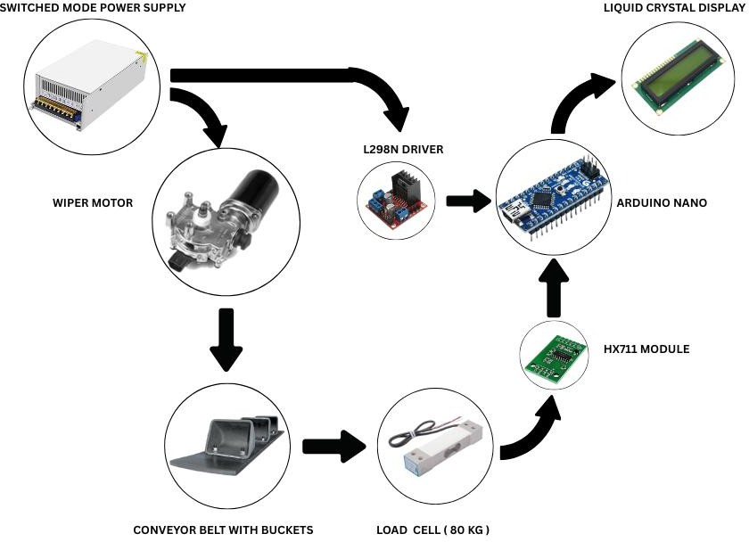
Fig. 5.1 – Block diagram

The block diagram (Fig 5.1) shows the flowing of data and the connection between each component present in the system. This gives an easy way connect and view the operation of the system. This gives the automated rice husk powder collection system using a microcontroller, load cell, and a conveyor belt system.
The Switched Mode Power Supply (SMPS) provides the required DC voltage to all components in the system. It ensures stable and efficient power for the motor, driver, and control units.
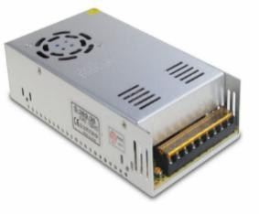
Fig. 5.2 – Switched mode power supply

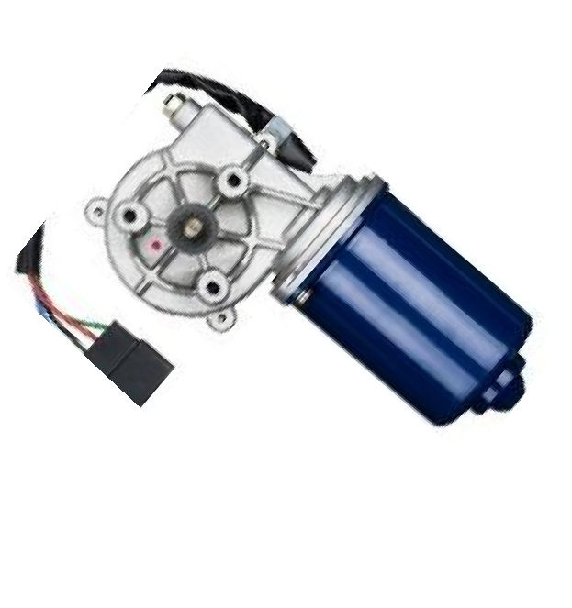
The Wiper Motor drives the conveyor belt. It rotates continuously when powered, enabling the buckets on the conveyor to carry rice husk powder from the collection point to the sack.

Fig. 5.3 – Wiper motor

L298N Motor Driver acts as an interface between the Arduino Nano and the wiper motor. It receives control signals from the Arduino and supplies the required power to drive the motor in the desired direction.
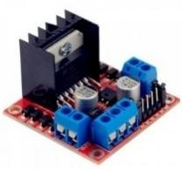
Fig. 5.4 – L298N motor driver

Conveyor Belt fitted with buckets is responsible for collecting and transporting the rice husk powder. As the belt moves, it lifts the powder and drops it into a sack for storage.
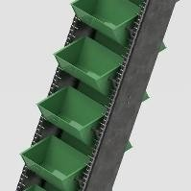

Fig. 5.5 – Conveyor belt

Load Cell (80 kg) measures the weight of the rice husk being collected in the sack.
It converts the weight into an electrical signal.
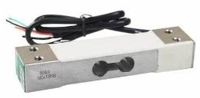

Fig. 5.6 – Load cell (80 Kg)

HX711 Module reads the output from the load cell and converts it into a digital value. It sends this data to the Arduino for processing.
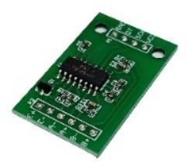
Fig. 5.7 – HX711 module

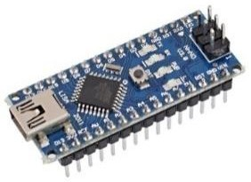
Arduino Nano receives weight value from the HX711, processes it and then sends data to the LCD display.

Fig. 5.8 – Arduino Nano

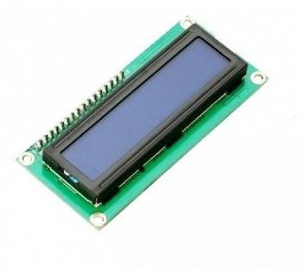
Liquid Crystal Display (LCD) shows the current weight of the rice husk being collected. This helps monitor the collection process in real time.

Fig. 5.9 – Liquid Crystal Display

This system helps automate the rice husk powder collection, reduce manual work, and improve accuracy in monitoring the collected weight.

CIRCUIT DIAGRAM
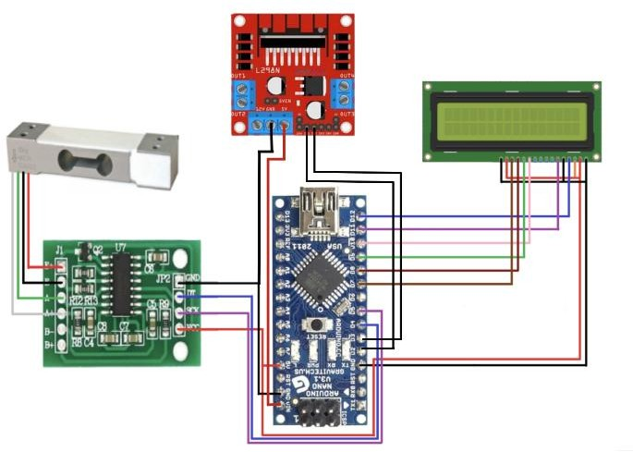

Fig. 5.10 –Circuit diagram

This circuit diagram shows the different components in the rice husk powder collection system that are connected together. At the centre is the Arduino Nano, which is the main controller of the system.
The load cell is used to measure weight which sends the analog reading of the weight to the HX711 module which then convert it into digital form for Arduino can understand. The HX711 is connected to the load cell on one side and to the Arduino on the other using two main wires: DT (data) and SCK (clock).
Then the 16x2 LCD display that shows the real time weight reading. It’s connected to the digital pins on the Arduino to control the display of characters as shown in the Fig.
5.10. This helps in real time viewing of the rice husk that has been collected.

The L298N motor driver module shown here is the power source of the components that are used in the system. It powers the Arduino Nano and the LCD with a constant supply. The direct AC supply is given to the SMPS and then from there the supply is given to the driver.
Overall, the system is a simple and effective setup for monitoring rice husk collection with real time monitoring of the weight of the collected powder.

3D VISUALIZATION

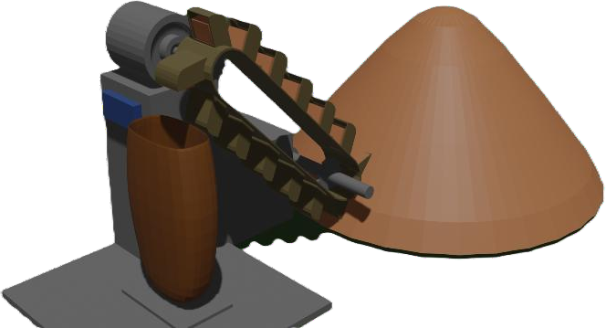

Fig. 5.11 – 3D Model

The 3D visualization gives us a basic idea of how the entire setup looks and works in real life. It helps us see where each part is placed which includes the conveyor belt, the frame, the motor, the load cell, and the collection bucket at the bottom.
Everything is shown together, so during the manufacturing process it is easy to build without any errors thus speeding up the making process with more precision and with less errors.
This model shows how the conveyor is slightly slanted, so the powder moves down smoothly without getting stuck. The frame holds everything in place and makes sure the system is stable. It also shows us where we can safely place the electronic parts like the Arduino and the HX711 module without disturbing the working parts.
This 3D model helps in the presentation of the idea to the manufacturer to get a rough idea of what the final outcome will be and it helps in explain the model to the necessary people which can be easily understandable.
This model is done with the help of Blender software with accurate measurements for the manufacturing process.

SYSTEM STRUCTURE
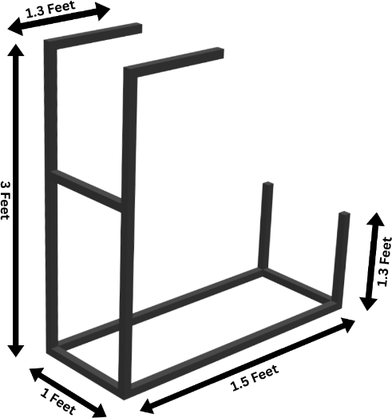
Fig. 5.12 – Metal structure

This metal frame is the main support for the conveyor belt and the collection system in the rice husk powder setup. It's built with strong 1inch thick metal square pipes that give it the strength and durability needed to hold everything in place.
The base of the frame is 1.5 feet long and 1 foot wide, making it compact but stable enough to handle the load.
The front has two vertical rods that are 1.3 feet tall, while the back has taller rods at 3 feet. This height difference creates a slight slope for the conveyor belt, allowing the rice husk powder to move smoothly.
There's a horizontal crossbar between the back vertical rods for added strength and support for the conveyor belt.
At the bottom, two more vertical rods, each 1.3 feet tall, hold the sack or container that collects the rice husk powder as it falls off the belt. This setup ensures that the powder goes directly into the collection sack without spilling.
The frame design is simple, easy to construct, and fits well in tight spaces like a rice mill or workshop. It keeps everything aligned, prevents unwanted movement during use, and provides a reliable platform for operating the conveyor and checking the weight.

CHAPTER 6

SYSTEM COMPONENTS

COMPONENTS

S.no | Components
 | Name | Quantity | Details
1 | Wiper motor | 1 | 12V
2 | Load cell | 1 | 80 Kg
3 | HX711 module | 1 | -
4 | L298N Driver | 1 | -
5 | Arduino | 1 | Nano
6 | Switched Mode Power Supply | 1 | 12V, 60A
7 | Steel | 20 feet | 1 inch
8 | Conveyor belt and buckets | 8 feet, 8 | -
9 | Bearing | 4 | -

Table 6.1 – Components required

SOFTWARE USED

Arduino IDE - To program the Arduino nano

Blender - To make the 3D model

CHAPTER 7

RESULTS AND DISCUSSION

POWDER COLLECTION
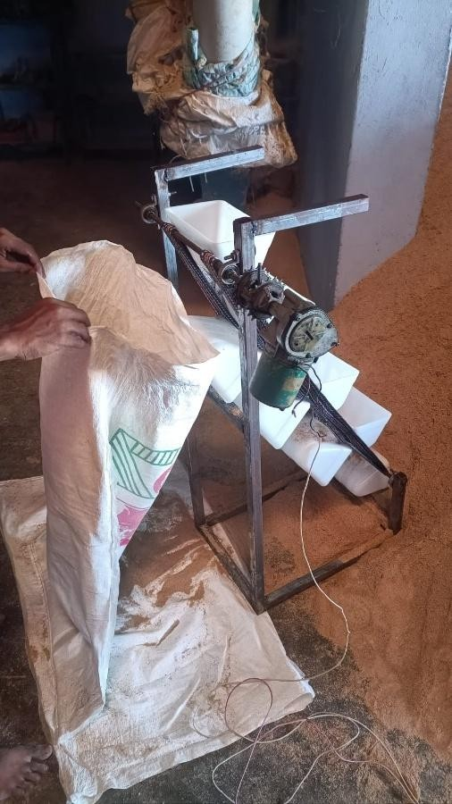

Fig. 7.1 – Whole system
The developed system is designed to monitor the weight of rice husk powder collected through a conveyor setup. It combines mechanical movement and electronic monitoring to assist in handling bulk husk in rice mills. The main goal is to reduce manual effort in weight estimation by introducing a real-time digital display system.

Using a load cell and an Arduino Nano, the setup displays the amount of collected powder on an LCD, making it easier for users to know the weight without any guesswork. The system is cost-effective, simple, and suitable for small to medium-scale applications.

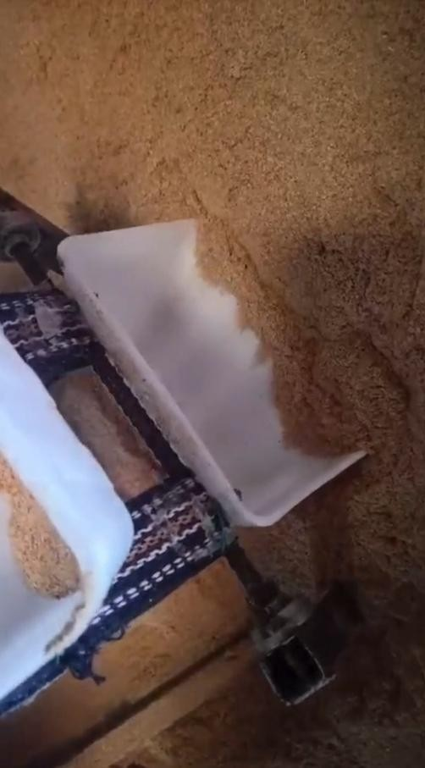

Fig. 7.2 – Power collected from the pile

The image shows how the rice husk powder is collected at the bottom of the system. As the conveyor moves, the small buckets carry the powder and drop it down into the collection sack placed.
The frame holds this container steady so the powder falls directly into it without spilling. This setup makes it easy to collect the powder in one place and helps reduce the need for manual cleaning or scooping. It’s a simple and neat way to gather the powder after it’s been picked up from the ground.

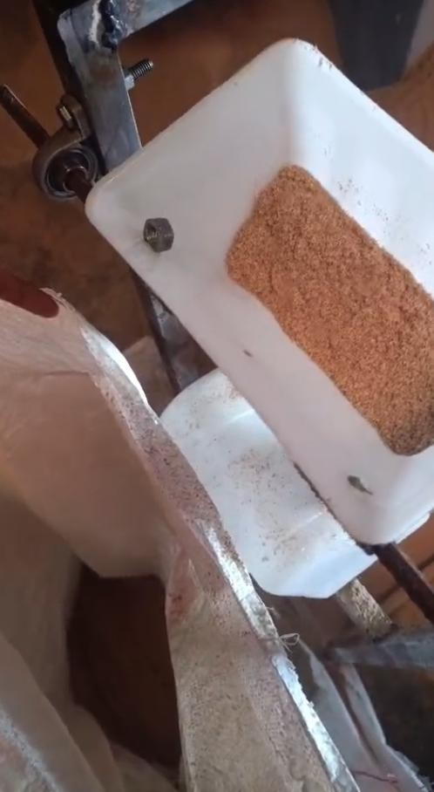

Fig. 7.3 – Powder dropping into the sack

The above shows how the collected husk powder from the pile is thrown into the collection sack for further packaging process. The whole belt system is driven with the help of the wiper motor at the top.
As the belt moves, these buckets collect the powder from one end and drop it into the collection sack at the other end.
The conveyor’s steady motion ensures a consistent flow, preventing sudden loads or overflows, and improving the overall cleanliness and organization of the workspace.

WEIGHT MEASUREMENT
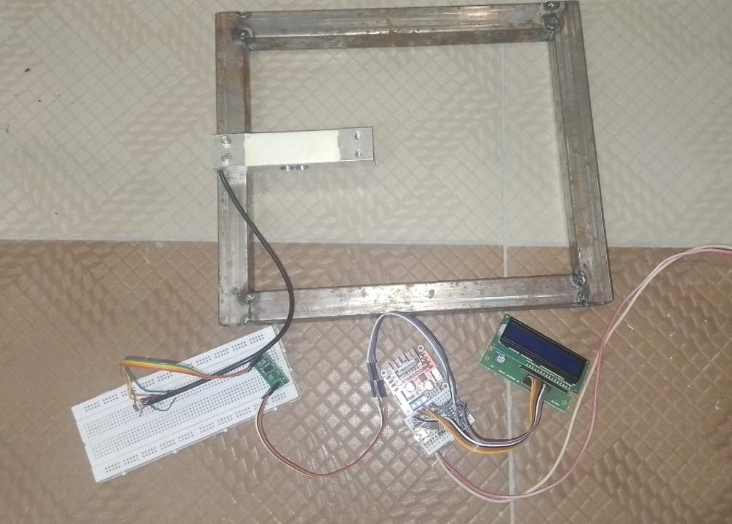

Fig. 7.4 – Weight measuring system

The weight measuring part of the system is what brings the "smart" factor into the design. A load cell capable of measuring up to 80 kilograms is placed right below the sack where the husk powder is collected. As the weight of the material increases, the load cell bends slightly and sends a tiny analog voltage signal proportional to the weight.
This signal is very small and needs amplification—this is done by the HX711 module, which also converts the signal into a digital format. The Arduino Nano then reads this digital data and processes it to calculate the actual weight.
The value is continuously displayed on a 16x2 LCD screen, making it easy for the user to track the weight in real-time. This removes the guesswork from the collection process and ensures that sacks are not overfilled or underused.
The system is simple yet effective, providing a low-cost, reliable solution for automated weight monitoring without requiring any external scale.

DISCUSSION
The system performed well during testing, accurately displaying the collected weight on the LCD in real-time. It made the entire process of monitoring rice husk collection more efficient and required less human effort.
The readings were stable and responsive, which shows the reliability of the load cell and HX711 module combination.
Although the conveyor motor is not automatically controlled by the system, the weight display gives users a clear idea of when to stop or switch sacks.
Overall, the setup offers a practical solution for improving operations in rice mills, especially where manual labour is high and time efficiency is important.

CHAPTER 8

CONCLUSION AND FUTURE SCOPE

CONCLUSION

The rice husk powder collector system was successfully developed to help reduce manual work and make the powder collection process more efficient. By using a conveyor belt system, the collected rice husk powder is moved efficiently and neatly to the collecting sack, which helps reduce labour force and effort. The addition of a load cell and display allows the weight of the collected powder to be monitored easily in real-time, giving better control over the process.
The entire setup is built on a metal frame made using 1-inch square pipes, which keeps everything stable and in place during operation. This project solves an industry problem with simple mechanism that combines both electronics and mechanical parts for greater efficiency. Overall, the system is simple, budget-friendly, and useful for small-scale rice mills or processing units to manage rice husk waste in a cleaner and easier way.

FUTURE SCOPE
There are many ways this project can be improved in the future. One major upgrade could be adding automation features, like making the conveyor belt stop automatically when the sack reaches a preset weight. This would reduce the need for manual monitoring.
A buzzer or alert system could also be included to notify when the collection is full. Another addition would be wireless data transmission using Bluetooth or Wi-Fi, which would allow the collected weight data to be sent to a mobile phone or computer for better tracking and record-keeping.
With more features, this project can be turned into a smart and fully automated industrial solution for rice husk powder and other types of materials to be handled with better accuracy and ease of use.

CHAPTER 9 REFERENCES
- Lim, J. S., Hashim, H., Manan, Z. A., & Alwi, S. R. W. (2012). Optimal Design of a Rice Mill Utility System with Rice Husk Logistic Network. Industrial & Engineering Chemistry Research, 51(14), 5167–5176.
- Mhambure, T. (2017). Adaptable, Automated Product Weight Monitoring Conveyor System with SCADA.
- Thungu, G. (2019). Design and Implementation of Infrared Load Sensor for Power Saving in Conveyor Belts.
- Sharma, R., Kumar, A., & Patel, S. (2023). Automated Rice Husk Powder Collection System Using Conveyor Belt and Load Cell for Weight Monitoring. International Journal of Agricultural Engineering and Automation, 5(2), 55–62.
- KARP Machinery Co. Ltd. (2020). Vibrating Screening and Belt Conveyor for Testing Rice Husk.
- Multivent Engineers. (n.d.). Rice Husk & Pneumatic Husk Conveying System.
- Laitram, L.L.C. (2015). Weighing System Using a Conveyor Belt with Load Cells.
- Kumar, P., & Singh, R. (2020). Design and Development of Automated Material Handling System for Rice Husk. Journal of Mechanical Engineering and Automation, 10(3), 45–50.
- Lee, J. H., & Park, S. Y. (2018). Development of a Load Cell-Based Weight Monitoring System for Agricultural Conveyors. Agricultural Engineering International: CIGR Journal, 20(2), 100–107.
- Yadav, S., & Jha, R. (2021). Arduino-Based Weight Measurement System Using Load Cell and HX711 Module. International Journal of Engineering Research & Technology (IJERT), 10(5), 412–416.
- Suryawanshi, M. et al. (2018). Smart Conveyor System Using Arduino for Material Handling and Weight Sensing. International Journal of Computer Science and Mobile Computing, 7(4), 88–92.

- Sharma, R. et al. (2022). Wiper Motor-Based Automation for Agricultural Application Using Arduino. International Journal of Mechanical and Production Engineering, 12(9), 95–99.
- Budiasto, J., et al. “Load Cell Technology in the Rice Holding Capacity Monitoring System at MKP Rice Milling in the Malind District”, Jurnal Info Sains, Vol.14, No.3, 2024, pp.400–406.
- Random Nerd Tutorials. “Arduino with Load Cell and HX711 Amplifier (Digital Scale)”, 2022.
- Kannaki, S., Karthigai Lakshmi, S., Harish, V., & Saktheeswaran, G. (2019). Development of Advanced Automatic Sorting Machine Using Weighing Mechanism. International Journal of Recent Technology and Engineering, 8(3), 1704–1708.
- Djokorayono, R. (2021). Design of Belt Conveyor Weight Scale Using Gamma Radiation Technique.
- Mhambure, T. (2017). Adaptable, Automated Product Weight Monitoring Conveyor System with SCADA.
- Fourney, M. L. (2015). Weighing System Using a Conveyor Belt with Load Cells.
U.S. Patent No. 9,004,271.
- UniProjects Team (2018). Design and Construction of a Conveyor Belt with Weight Sensor.
- MyProjectCircuits Team (2019). Design and Construction of a Conveyor Belt with Weight Sensor.

